**Technical Documentation – Salesforce assignment**

Part 1: **Trigger**

**Design Considerations:**

1. Contact.Account_Industry__c field always reflects account Industry and any direct change to the field ‘Account_Industry__c’ on contact UI/data update will be overridden by the trigger
2. Existing contacts [before deploying the code] needs one time data patch to sync Account’s Industry to Account_Industry__c
3. NOT in SCOPE: Account.Industry update will not change the contact industry as part of this code. Another trigger/custom logic on account would do that part

*Alternative solution for this scenario* on salesforce would Formula field on Contact

**Components:**

|  |  |  |
| --- | --- | --- |
| **Type** | **Name** | **Comments** |
| Trigger | ContactTrigger.trigger | * **Before Insert** and **Before Update** events were considered [no DML required] * Trigger.Opertiontype to route to different triggerHandler methods |
| Classes | ContactTriggerHandler.cls | * BeforeInsert method to receive only trigger.new param and pass it to helper * BeforeUpdate method to receive two params trigger.new and trigger.Oldmap * Both methods will call same method from ContactTriggerHelper. copyAccountIndustrytoContact |
|  | ContactTriggerHelper.cls | * All data manupulation happens copyAccountIndustrytoContact(newContacts, oldContactMaps) * Collect all accountId from newContacts and query on account to fetch account.Industry maps. * Loop through newContacts and populate Account_Industry__c in following conditions * Check for if it’s new contact by checking oldContactMaps = null and update value from map to newContact * For Update, if c.Account_Industry__c == null [existing contacts]   Or check current Account is changed  Or check if current contact and old Contact has different Account_Industry__c |
|  | ContactTriggerTest.cls | Test class with following unit test scenarios  *TestCase1:* Create new contact and verify if account_Industry is populated  *TestCase2:* update existing contact with different account and verify if correct account_Industry is populated  *TestCase3:* update existing contact with different account Industry than it's account's and verify if correct account_Industry is populated |

**2. Lighting Web Component**

**Design Considerations:**

1. To Include LWC inside VF page, standalone aura app is created [VFLWCApp.app] and embedded using $Lightning.use()
2. Included OOB features included to build UI – no custom CSS is applied
3. To make only single account selection – lightning-datatable max-row-selection="1" property used.

Next button visible only if any account radio button selected.

1. Following requirement is met with OOB lightning-datatable row selector feature. Selected row displayed as light grey

“When an Account is selected there should be CSS applied to indicate what Account is selected.”

1. Per requirement only 5 accounts were shown in list page.

**To view this in action**: Please visit app ‘Affirm Assignment’ and click ‘LWC Demo’ tab in the salesforce env provided

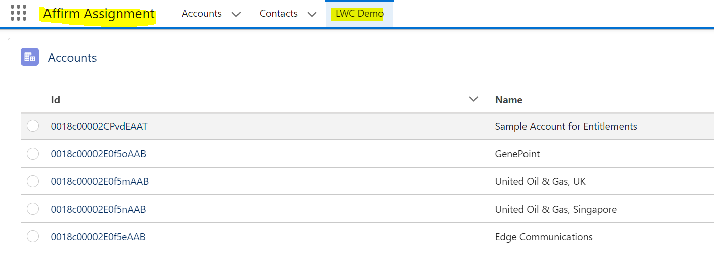

**Components:**

|  |  |  |
| --- | --- | --- |
| **Type** | **Name** | **Comments** |
| page | LWCDemo.page | Script $Lightning.use is for embedding lwcAccountView |
| aura | VFLWCApp.app | Lightning standoup app with lwcAccountView depedency |
| LWC | lwcAccountView | Single component hold both List view and Account detail view. Visibility controlled via button clicks |
| Class | AccountDataController | Two @auraenabled(cache=true) LWC accissable methods created   1. getAccounts() – return 5 account data 2. getAccountDetail(accountId)- return account detail for account passed to the method. |